OSSP Practical:
Section:09
M. Sreeya
WEEK-6:
Server:
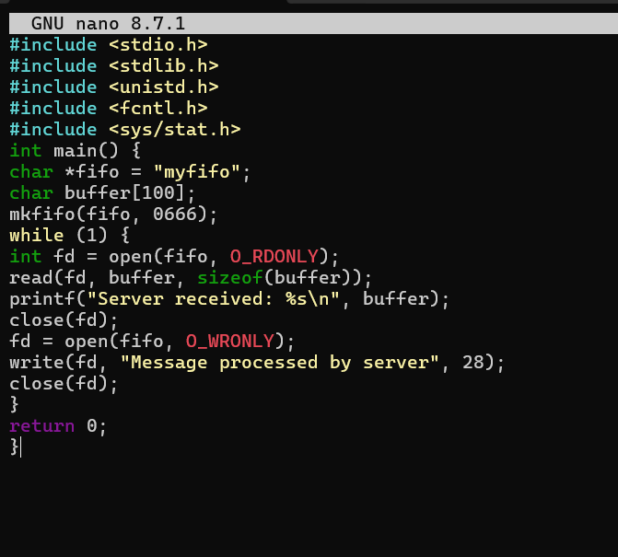
OUTPUT:
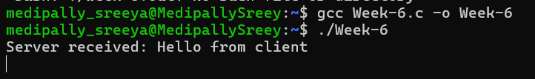

Client:
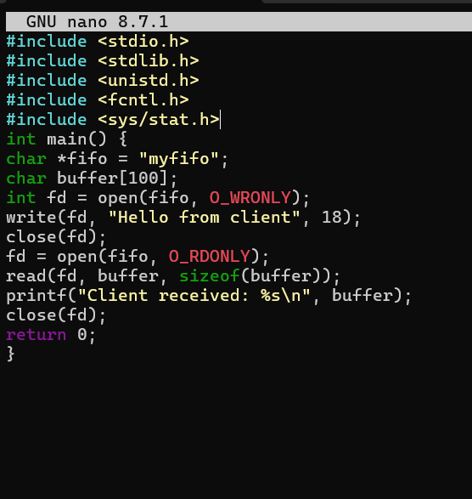
OUTPUT:
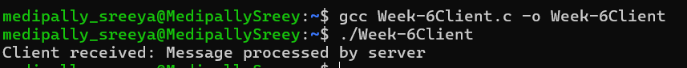

POSIX:
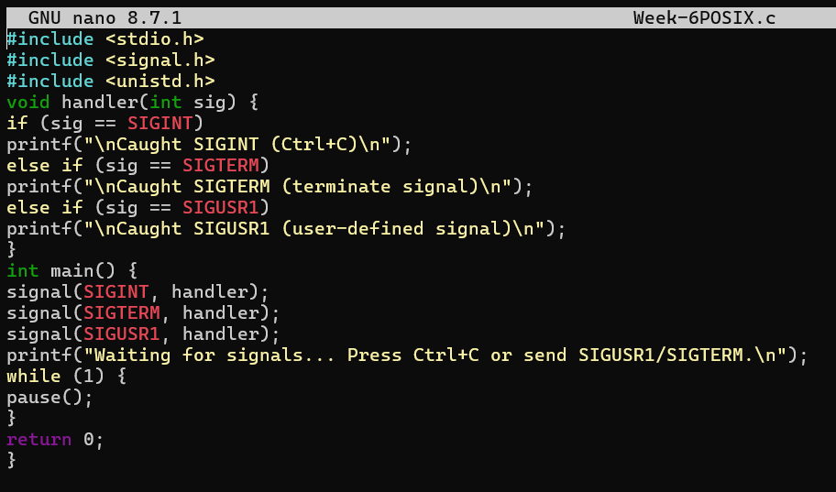
OUTPUT:
